
Department of Computer Science and Engineering
Islamic University of Technology (IUT)
A subsidiary organ of OIC

Lab Report 01

CSE 4616: Wireless Networks Lab

Section: 2A
Semester: Summer
Academic Year: 2020 - 2021
Date of Submission: 20th December, 2021

Title: Introduction to GNS3 and Wireshark

Diagram of the experiment:
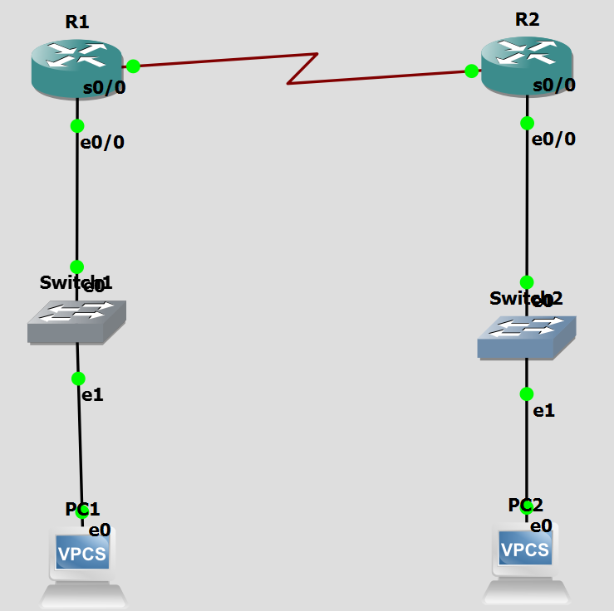

Working Procedure:
Setting PC IP Addresses:
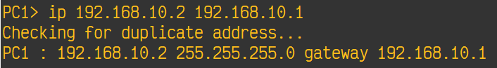
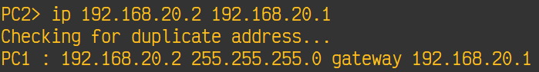

Configuring Routers:
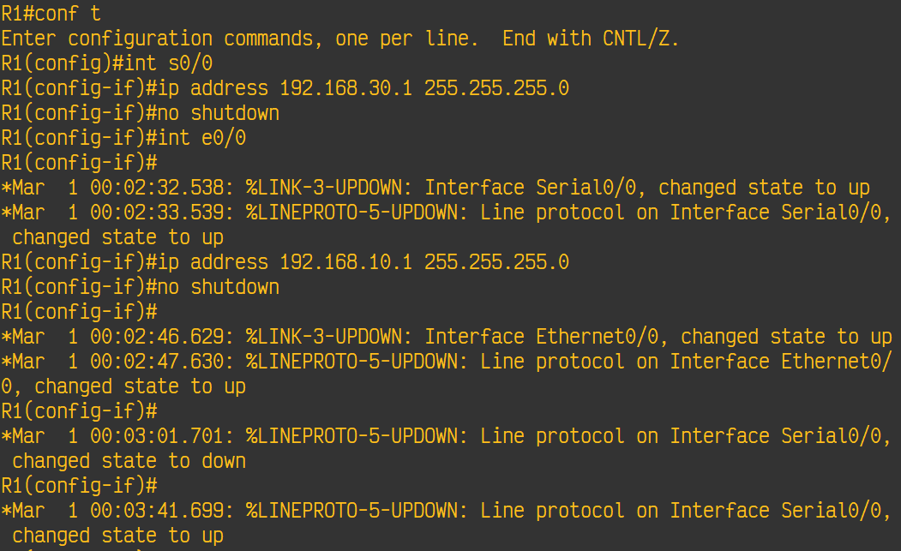
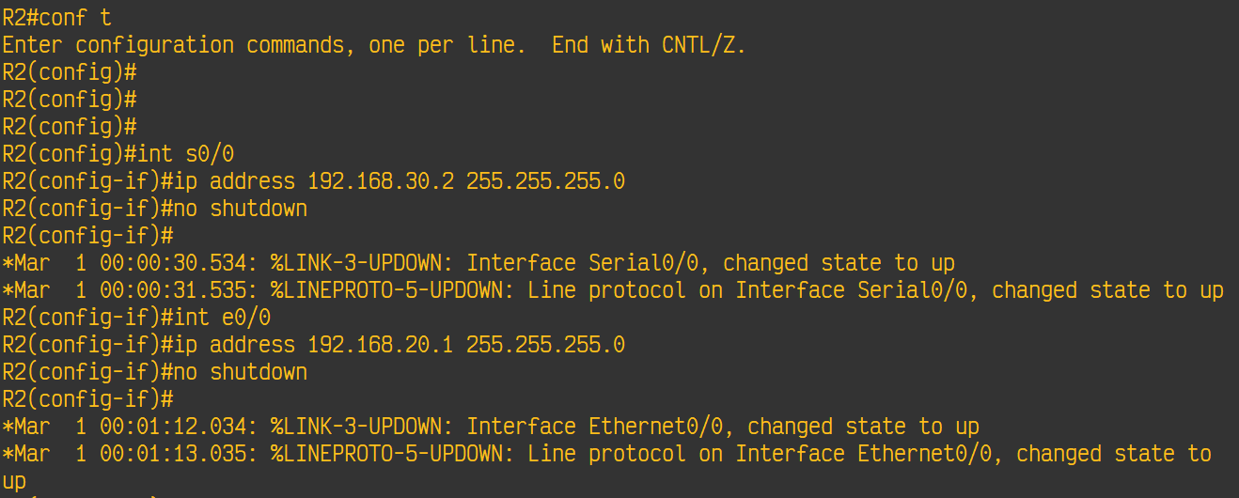

Configuring RIP:
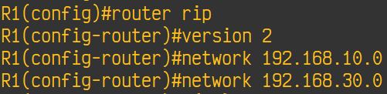
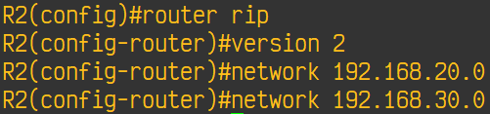
Ping:
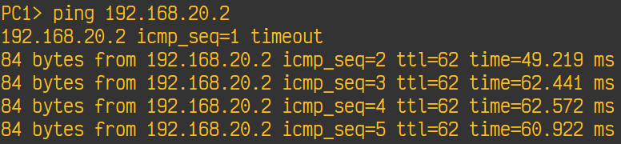

Capturing packets transmitted between R1 and R2:
